STEP 1. CREAT

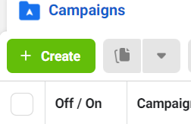

STEP 2. CAMPAIGN GOAL

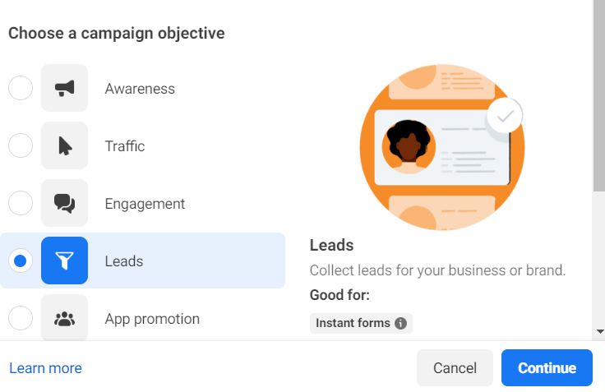

STEP.3 CHOOSE A CAMPAIGN SETUP

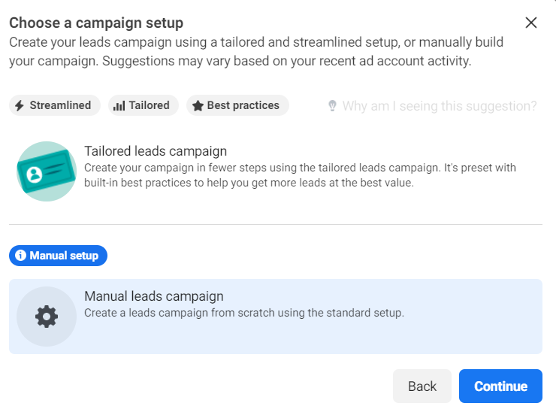

STEP 4. GIVE NAME OF CAMPAIGN

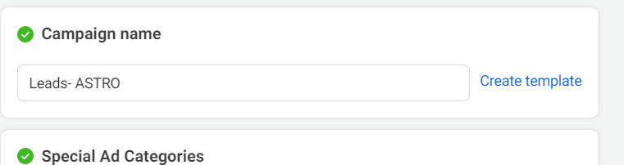

STEP 5. Name ad set

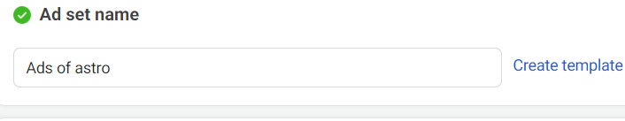

STEP 6. SELECT CONVERSION TYPE

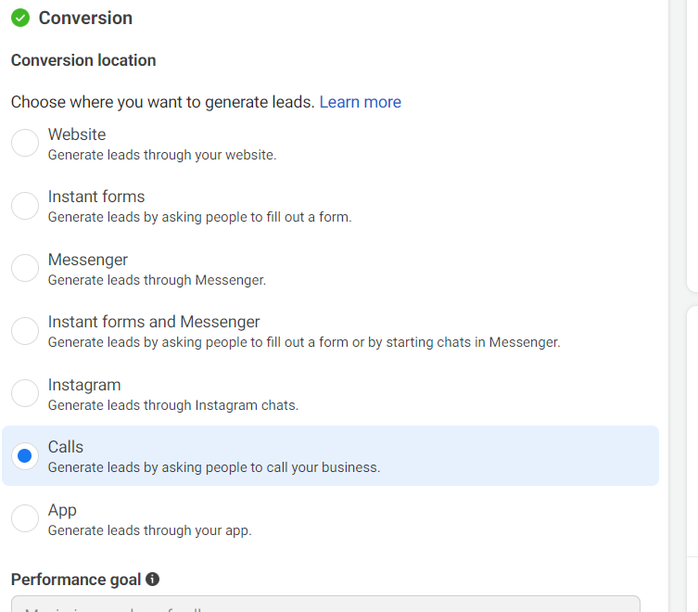

STEP 7. SELECT BUDGET AND SCHEDULE AD OR END DATE [OPPTIONAL]

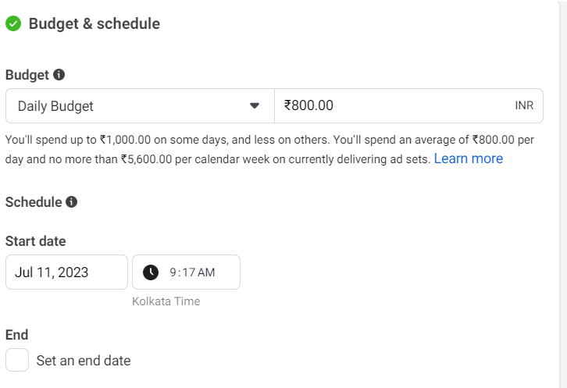

STEP 8. CHOSE LOCATION & AGE OF AUDIENCE AND GENDRE. YOUR AUDIENCE

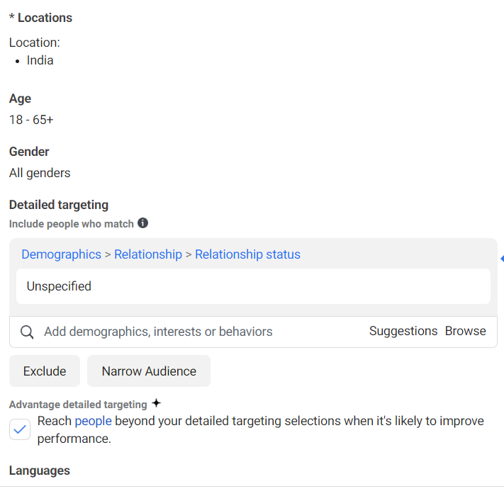

STEP 9: CHOOSE PLATFROM

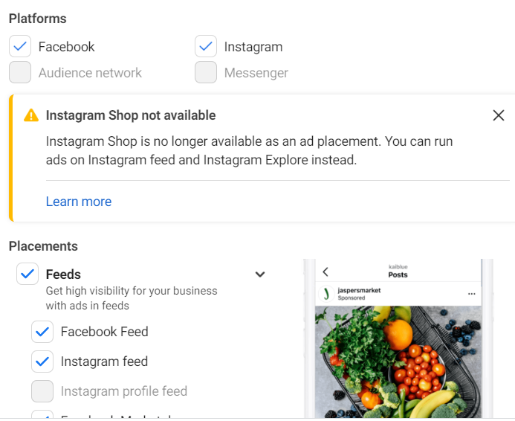

STEP 10. AD SETUP

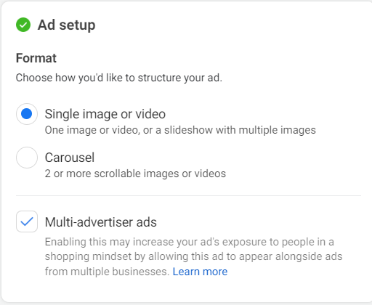

STEP 11. CREAT AD

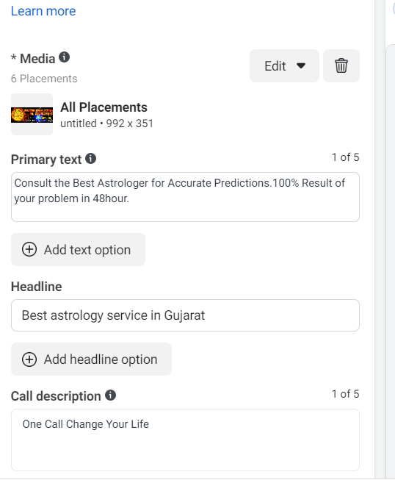

STEP 12. CALL SETTING

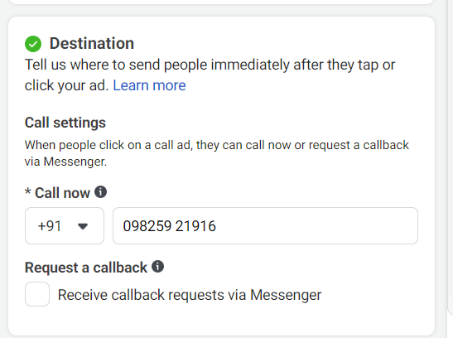

LAST STEP: PUBLISH AD

